1. 矩阵乘法加法计算器：[矩阵乘法计算器 (reshish.com)](https://matrix.reshish.com/zh/multiplication.php)

2. homogeneous transformation齐次坐标：<https://blog.csdn.net/zx3517288/article/details/79154036>

3. 矩阵表示Translation / Rotation / Scaling

4. 二次和三次贝塞尔曲线

ctx.quadraticCurveTo( p1x, p1y, p2x, p2y )

ctx.bezierCurveTo( p1x, p1y, p2x, p2y, p3x, p3y )

两个函数的转化公式：

<https://stackoverflow.com/questions/3162645/convert-a-quadratic-bezier-to-a-cubic-one/3162732#3162732>

workbook里说考试会考的题型

1.

**Workbook**

SVG画曲线

End of Week Survey 2

1.运行结果

产出：



2.

3.

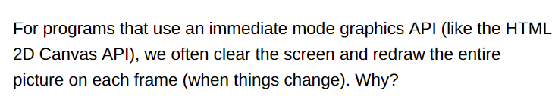

4.

5.

6.

Raster display

7.

Odd-even rule vs nonzero winding number rule

“nonzero规则” 是不是0，如果不是0则内部，填充；如果是0则外部，不填充。

“evenodd规则”是不是奇数，如果是是奇数则内部，填充；如果是偶数则外部，不填充。

[非零环绕数规则和奇-偶规则（Non-Zero Winding Number Rule&&Odd-even Rule）_freshForIphone的专栏-CSDN博客_非零环绕数规则](https://blog.csdn.net/freshforiphone/article/details/8273023)

8.

Double buffering allow us achieve:

End of Week Survey 4

1.

2.

False

3.

图形和对应code

4.

homogeneous transformation

A translation by 5 in the x direction and 10 in the y direction:

A reflection about the Y axis:

A rotation by -90 degrees (-PI/2 radians)

5.

6.

the position of the moveTo command (the start of the line) would be 10 "canvas pixels" to the right (of the left edge of the canvas)

 the position of the moveTo command (the start of the line) would be 10 "canvas pixels" down from the top

因为The second context.translate(10,0) (on line 4) moves the position 10 "canvas pixels" down from the top, because context.rotate(Math.PI/2) makes X-axis pointing down.

The segment goes from (10, 0) to (10, 10), so it is vertical.

7.

8.

Scale和translate

End of Week Survey 5

1.

2.

3.

4.

5.

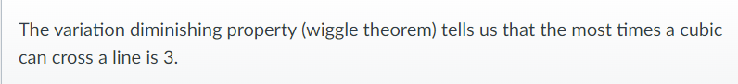

6.

7.

8.

